**School of Science and Technology**

**B.Sc. in Computer Science and Engineering**

**Lab Report : 02**

**Designing Use Case Diagram of a Clinic (TogetherSoft Inc.)**

|  |  |
| --- | --- |
| **Submitted By** | **Submitted To** |
| Name: **Md. Zubaer Ahammed**  Student ID: 20-0-52-801-006  Course Title: Database Management System Lab  Course Code: CSE22P9 | **Mr. Samrat Kumar Dey**  Lecturer (Computer Science),  School of Science and Technology  Bangladesh Open University  Gazipur-1705 |
| **Date of Submission: 15 Mar 2024** | |

**Objective:**

The objective of this lab report is to design a use case diagram illustrating the " Designing Use Case Diagram of a Clinic" using EdrawMax or Equivalent software. This diagram will illustrate the various interactions between actors and the system, helping to understand the functionality and behavior of the system.

**Theory:**

UML (Unified Modeling Language) is a standardized modeling language used in software engineering for visualizing, specifying, constructing, and documenting software systems. A Use Case Diagram in UML represents the interactions between external actors (users) and the system to achieve specific goals. It illustrates the functionalities of a system from the user's perspective.

* **A use-case diagram is a set of use cases**
* **A use case is a model of the interaction between**
* **External users of a software product (actors) and**
* **The software product itself**
* **More precisely, an actor is a user playing a specific role**
* **describing a set of user scenarios**
* **capturing user requirements**
* **contract between end user and software developers**
* **Actors:** A role that a user plays with respect to the system, including human users and other systems. e.g., inanimate physical objects (e.g. robot); an external system that needs some information from the current system.
* **Use case:** A set of scenarios that describing an interaction between a user and a system, including alternatives.
* **System boundary**: rectangle diagram representing the boundary between the actors and the system.

* Association:

communication between an actor and a use case; Represented by a solid line.

* Generalization: relationship between one general use case and a special use case (used for defining special alternatives) Represented by a line with a triangular arrow head toward the parent use case.

* Association: a dotted line labeled <<include>> beginning at base use case and ending with an arrows pointing to the include use case. The include relationship **occurs** when **a chunk of behavior is similar** across more than one use case. Use “include” in stead of copying the description of that behavior.

* Extend: **a dotted line** labeled <<extend>> with an arrow toward the base case. The extending use case **may add behavior to the base use case**. The base class declares “extension points”.

**Required Software:**

For designing the flowchart of the General Problem Solution Approach, EdrawMax or any equivalent software capable of creating flowcharts can be used.

**Procedures:**

Open EdrawMax or equivalent software.

Select the option to create a new UML diagram.

### 1. Identify Actors:

Determine the primary actors interacting with the system. In a clinic management system, actors could include patients, doctors, receptionists, and administrators.

### 2. Identify Use Cases:

Define the functionalities the system should perform to meet the needs of its users. Use cases for a clinic management system may include scheduling appointments, managing patient records, prescribing medication, billing, etc.

### 3. Draw Use Case Diagram:

Use eDrawMax or any equivalent software to create the UML Use Case Diagram.

Start by drawing a box representing the system boundary.

Inside the boundary, place actors (represented by stick figures) and use cases (represented by ovals).

Connect actors to the use cases they participate in with solid lines, indicating associations or interactions.

Add multiplicity if an actor participates in multiple instances of a use case.

Include include-extends relationships if certain use cases extend others.

* Both **Make Appointment** and **Request Medication** include **Check Patient Record** as a subtask (include)
* The **extension point** is written inside the base case **Pay bill**; the extending class **Defer payment** adds the behavior of this extension point. (extend)
* **Pay Bill** is a parent use case and **Bill Insurance** is the child use case. (generalization)

### 4. Refine and Validate:

Review the diagram for accuracy and completeness.

Ensure that all necessary actors and use cases are included.

Validate the diagram with stakeholders to confirm that it accurately represents the requirements and functionalities of the Clinic Management System.

Finally, Save the UML diagram once it accurately represents the expected Use Case diagram of the clinic (TogetherSoft Inc.).

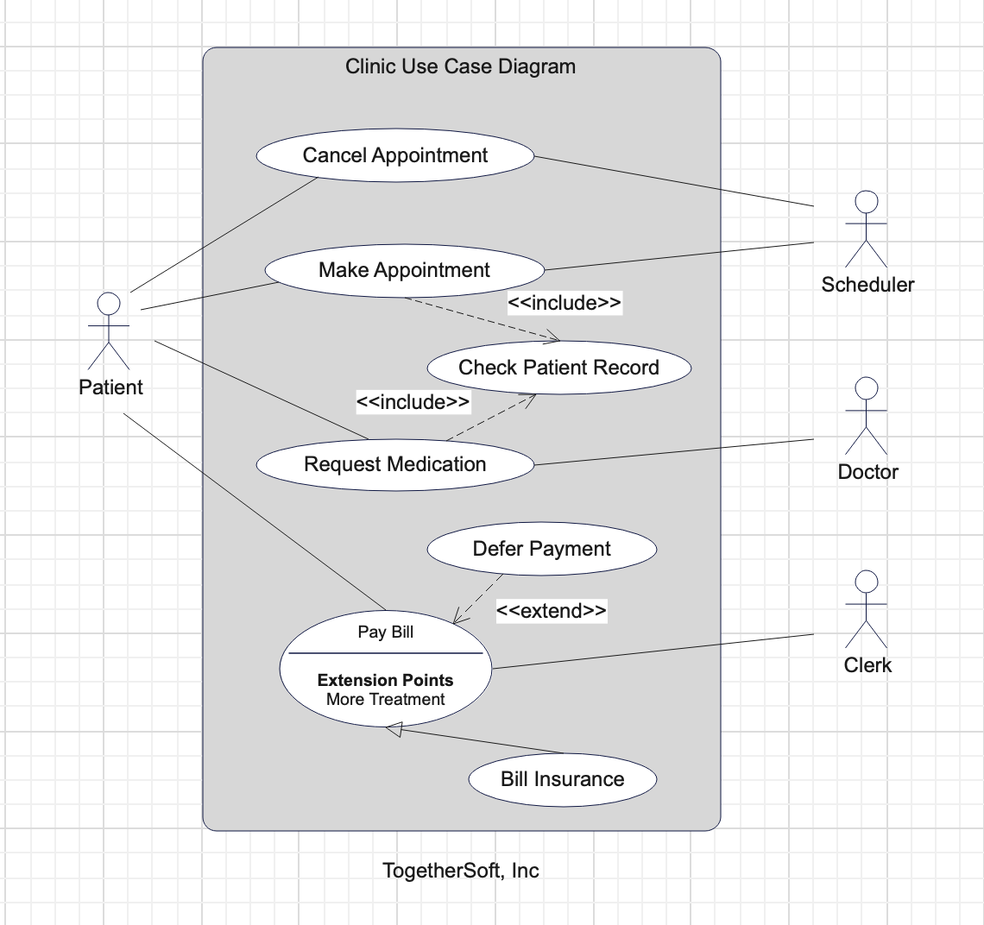

**Conclusion:**

In conclusion, designing a UML Use Case diagram of the General Problem Solution Approach provides a structured framework for effectively addressing and solving problems. By following the defined steps, individuals and organizations can streamline their problem-solving process, leading to more efficient and successful outcomes. Utilizing software such as EdrawMax facilitates the visualization and documentation of the problem-solving process, enabling clear communication and collaboration among stakeholders. Overall, the flowchart serves as a valuable tool for guiding problem-solving efforts and driving continuous improvement.